Péter Bártfai

personal data

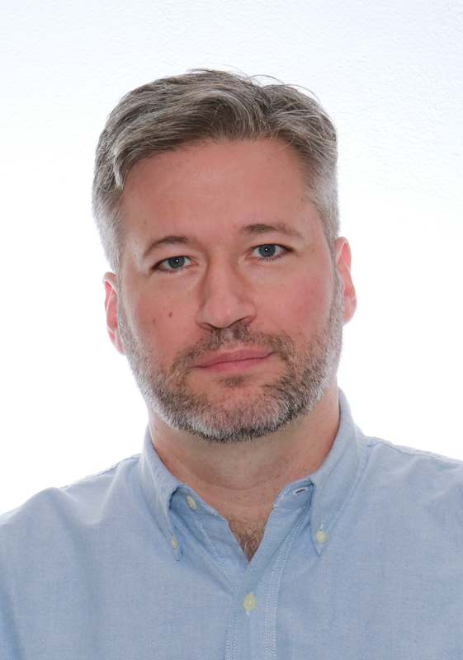

Date of birth 27th of February 1974

Place of birth Nyíregyháza, Hungary

Permanent Address 2151, Fót, Levendula utca 5. Hungary

Phone +36-20-3966285

E-mail [peter.bartfai@stardust.hu](mailto:peter.bartfai@stardust.hu)

Marital status married

Nationality Hungarian

Experience

2008- [Orange Business Services](http://www.orange-business.com/) Budapest

Avaya/Genesys Consultant

2003- [LDView](http://ldview.sourceforge.net/) Budapest

Open-Source Developer

2005-2008 [Avaya Hungary Ltd](http://www.avaya.com/). Budapest

Telecommunication Support Engineer

2001-2005 eTel Hungary Ltd. Budapest

ISP Network Developer Engineer

2000 Novacom Telecommunication Ltd. Budapest

Network Planning Engineer

1997-2000 [ING Bank Rt.](https://www.ing.nl) Budapest

Telecommunication Engineer

1996–1997 Ericsson Traffic Lab Budapest

Software Developer, Network measurement and monitoring system

1995-1996 Telia AB & TUB-DTT HSNLab Budapest

Software Developer, Development of 'Experimental Multimedia over ATM’

SKILLS

Genesys Cloud CX

[Avaya](http://www.avaya.com) [Communication Manager](http://www.avaya.com/usa/product/avaya-aura-communication-manager/), [Call Center Elite](http://www.avaya.com/usa/product/avaya-aura-call-center-elite/), CMS, IQ, AES, [Experience Portal](http://www.avaya.com/usa/product/avaya-aura-experience-portal/), System Manager, Session Manager, [Messaging](http://www.avaya.com/usa/product/avaya-aura-messaging/), SIP, H.323, Desktop Wallboard, One-X Agent, [Call Recording](http://www.avaya.com/usa/product/avaya-aura-workforce-optimization/)

Design Call Center, Unified Communication, IP Telephony, IP Network

Troubleshooting Avaya voice systems, Cisco IP networks

Reporting Development of non-standard reports

Virtualization VMWare [vSphere](https://www.vmware.com/products/vsphere/)/vCenter/ESXi

Network Cisco IOS/Routers/Catalyst Switches

Protocols Ethernet, ATM, Frame Relay, ISDN, TCP/IP, MPLS VPN, BGP, OSPF, L2TP, IPsec, SDH, VoIP, H.323, SIP, SNMP

Protocol Analyzer [Wireshark](https://www.wireshark.org/)

Programming Unix C, C++, Perl, Python, Shell Scripts

Open Source Dev. [Qt](http://www.qt.io/), Git

Administrating Linux

Internet HTML, [PHP](http://php.net/), [MySQL](http://www.mysql.com/), CGI, Web/Mail server

Language English (professional)

Misc. Driving License, MPEG Technology

Education

1992-1997 [Technical University of Budapest](http://www.bme.hu/), Hungary

*Title of M.Sc. work: Network measurement and monitoring system*

1988-1992 Krúdy Gyula High School, Nyíregyháza

Certifications

GCP